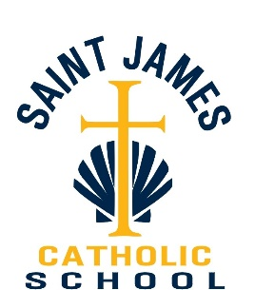

2602 Buffalo Road Erie, Pennsylvania 16510 814.899.3429

St. James School

COVID-19 Return to Safe Play Plan
(RTSP Plan) as of 10/28/2021

Our response to COVID – 19 for the St. James School Athletic Program is to mitigate the risk of the spread of this disease. St. James School/Erie Catholic School System has developed the following guidelines and recommendations based on the PA Department of Health and the Center for Disease Control (CDC). As more public health information is available, administration will work with our students and coaches to release further guidance which could impact our athletic season(s).

Introduction:
The COVID-19 virus is a highly contagious illness that primarily attacks the upper respiratory system. The virus that causes COVID-19 can infect people of all ages. Research from the Centers for Disease Control and Prevention (CDC), among others, has found that while children do get infected by COVID19, relatively few children with COVID-19 are hospitalized. However, severe outcomes have been reported in children, and a child with a mild or even asymptomatic case of COVID-19 can spread the infection to others who may be far more vulnerable. While it is not possible to eliminate all risk of furthering the spread of COVID-19, the current research suggests there are many steps schools can take to reduce the risks to students, coaches, and their families.
This document lays out guidance and best practices along with St. James School specific policies, outlined either in congruence with or increased precaution in reference to the guidelines provided. An appendix has been added with helpful information from the CDC regarding COVID-19 and the PA Department of Health.
It is important to note that the St. James School Athletics Return to Safe Play Plan (RTSP) is a fluid plan and will evolve as more information becomes available and guidelines from the Department of Education, the state of Pennsylvania, and the Department of Health evolve. St. James School and the Erie Catholic School System is committed to navigating any changes to this situation, and to make adjustments to the plans as needed. St. James School and the Erie Catholic School System will strive to minimize the overall effects of COVID-19. The health and safety of our entire school community remains our priority. No single precaution or strategy will completely eradicate COVID-19 or its transmission, though this plan will be flexible to address the possibility of varying conditions over time. Again, the guidance received places health and safety as paramount. The guidance is also rooted in the understanding and belief that social interaction and in-person instruction is essential to our students’ emotional well-being, as well as their educational growth and advancement.

Pre-workout/Pre-game Screening:
• We are asking all coaches and students to self-monitor for signs/symptoms of COVID-19 prior to attending a practice/game.
• Any person(s) displaying COVID symptoms will not be allowed to take part in practices/games and should contact his or her primary care provider or other appropriate health-care professional. A clearance may be required to return to play.
• Team attendance should be recorded

Limitations on Gatherings:
• The PIAA is no longer placing restrictions on group-size and/or capacity. The Erie Catholic School System, however, is limiting attendance to two individuals per player/participant.
- Cheerleaders will only cheer at home games.

• When not directly participating in practices or contests, social distancing should be considered and applied when able.
• Social Distancing should be applied during practices/games and in gathering areas.

Facilities Cleaning:
• Adequate cleaning schedules should be created and implemented for all athletic facilities to mitigate any communicable disease.
• Athletic facilities should be cleaned prior to arrival; high touch areas should be cleaned more frequently.

Physical Activity:
• Students should refrain from sharing clothing/towels and clothing/towels should be washed after each practice.
• Athletic equipment that may be used by multiple individuals (balls, shields, tackling dummies, shot put, discus, pole vault, etc.) should be cleaned intermittently during practice and events as deemed necessary.
• Hand Sanitizer should be used periodically as resources allow.

Hydration:
• Students MUST bring their own water bottle. Water bottles must NOT be shared!
• Hydration stations (water coolers, water fountains, etc.) should NOT be utilized, except for water-bottle filling stations.

Sidelines/Bench:
• Sidelines/Bench – appropriate social distancing will need to be maintained on sidelines/bench during contests and events, as deemed necessary by the school, PIAA, state and local governments. Consider using tape as a guide for students and coaches.
• Changes to seating capacity and social distancing may be necessary for each venue facility and will be determined as more recommendations are released by the local/state governments.

Overnight/Out of State Events:
• The school will evaluate each event and follow all local/state government guidelines on a case by case basis. Every consideration will be taken as to not expose students to unnecessary or potential high-risk exposure.
Concessions:
• Concession stands or other food must adhere to the Guidance for Businesses in the Restaurant Industry.

St. James School Athletic and Facility Use Policies, Procedures, and Protocols:
- St. James School staff will review and consider the CDC and PA DOH guidance on consideration for youth sports and work with the appropriate stakeholders to modify practices and games to mitigate the risk of spreading the virus. This includes focusing on individual skill building versus competition and limiting contact in close contact sports in conjunction with PIAA Guidelines.
- All students participating and their parent(s)/guardian(s) will be required to sign a “Participation Waiver for Communicable Diseases Including COVID-19” form (See Appendix). That form will need to be completed and on file before they are able to participate in any practices/events.
- The primary point of contact for all questions related to COVID-19 is Gina Brennan, Principal of St. James, gbrennan@eriecatholic.org , (814) 899-3429.
- Should a student or coach who has been within our facilities receive a positive test for COVID-19, or has a confirmed member of their household with COVID-19, we will immediately consult with and follow the most current guidelines of the Erie County Department of Health concerning the expectations for their return to play/coach.
- Should a student or coach who has been within our facilities receive a positive test for COVID-19, or has a confirmed member of their household with COVID-19, we will immediately consult with and follow the most current guidelines of the Erie County Department of Health concerning the expectations for use and cleaning of the facility or affected areas.

- Students who have been sent home from school to quarantine OR who are part of a group/class who have been sent home to quarantine SHOULD NOT participate in any practice and/or game until further notice is given from school administration.

- Students who have been fully vaccinated should present documentation to the school office, as this may lessen or eliminate the need to quarantine should the student-athlete come in contact with a COVID-positive individual.
- Student athletes or coaches who have symptoms of acute respiratory illness are expected to stay home and not come to practice/events until they are free of fever (100.4° F [37.8° C] or greater), signs of a fever, and any other symptoms for at least 24 hours, without the use of fever-reducing or other symptom-altering medicines (e.g. cough suppressants). The following symptoms may appear 2-14 days after exposure.

- Fever
- Cough
- Shortness of breath
- Sore throat
- Pneumonia
- Difficulty breathing
- Nasal congestion
- Any other symptom as identified by the Erie County Department of Health
- Educational materials will be made available to all students and families (included in the appendix at the end of this document) and coaches will review with all of their student-athletes’ symptoms of COVID-19, when to stay home from practice/events, and proper handwashing/sanitizing.

- All coaches, staff, and other adult personnel are at all times required to wear face coverings (masks or face shields), unless they have a medical or mental condition or disability, documented in accordance with the Americans with Disabilities Act, that precludes the wearing of a face covering. If a coach, staff member or adult personnel is affected in this way, they must confer with the principal before starting any coaching duties.
- Coaches and athletes must maintain appropriate social distancing at all times possible, including on the field of play, sidelines, dugouts, benches, and workout areas. During down time, athletes and coaches should not congregate.
- Coaches and athletic staff must monitor athletes for symptoms prior to and during practices/events. If individuals participating in sporting activities show symptoms, have a temperature of 100.4 degrees or higher, or are sick, they must be sent home.
- All athletes, coaches, and staff must bring their own water and drinks to team activities. Team water coolers for sharing through disposable cups are not allowed. Fixed water fountains should not be used; except for water-bottle filling stations.
- Activities that increase the risk of exposure to saliva must not be allowed including chewing gum, spitting, licking fingers, and eating sunflower seeds.
- Avoid shaking hands, fist bumps, or high fives before, during or after games and practices. Limit unnecessary physical contact with teammates, other athletes, coaches, officials, and spectators.
- Whenever possible, equipment should be properly disinfected between uses. For the time being, locker rooms and the weight rooms will remain closed, student-athletes should come ready to practices/events in appropriate attire. Notification will be sent out when this changes.

Education:
Staff, coaches, parents and student-athletes will be educated on the following:
• COVID-19 signs and symptoms
• Proper ways to limit exposure to COVID-19 (use of face coverings, hand washing, cough/sneeze into elbow, disinfecting high-touch surfaces, social distancing, avoid touching eyes, nose, face and mouth, no spitting, gum chewing, etc.)
• No Handshakes/Celebrations involving physical contact (high fives, fist/elbow bumps, chest bumps, hugging, etc).
• The content of this Return to Safe Play Plan
• Any pertinent COVID-19 information released by state/local governments, NFHS and PIAA
• Students should be prepared to come dressed for activity.
• Limit indoor activities and the areas used. Locker room use is currently curtailed.
• Student athletes should remain with their assigned groups during each workout and during daily workouts to limit the number of people they come in contact with.
• No students are allowed in training areas without the presence of an athletic trainer.

For all levels of athletics:

- Anyone who is sick must stay home.

- Educate athletes, coaches, and staff on health and safety protocols, including COVID-19 signs and symptoms.

- Plan in place if an athlete or coach gets sick.

- Intensify cleaning, disinfection, and ventilation in all facilities. Intensify cleaning and disinfection of shared equipment.

- Athletes and coaches MUST provide their own water bottle for hydration. Water bottles must not be shared. Touchless water re-fill stations may be used. Water fountains must NOT be used.

- Athletes, Coaches, and Staff will self-monitor/assess prior to any voluntary workout, practice, event or team meeting. The purpose is to check for signs and symptoms of COVID-19. Individuals with temperatures registering at 100.4 or higher will be sent home.

- Promote healthy hygiene practices, such as hand washing (20 seconds with warm water and soap) and coaches wearing a facemask according to the PA DOH current face covering order. Hand sanitizer will be available for team use.

- Face coverings will be worn at all times by all coaches. Coaches are to put on their face covering prior to leaving their vehicle upon arrival on site and continue to wear the face covering until returning to their vehicle after their team activity concludes.

- Athletes will wear face covering upon arrival on site, unless they fall under an exception listed by the current PA DOH Face Covering Order. Athletes must wear face coverings unless they are outdoors and can consistently maintain social distancing of at least six (6) feet. Athletes are not required to wear face coverings while actively engaged in workouts and competition that prevent the wearing of face coverings, but must otherwise wear face coverings when on the sidelines, in the dugout, and anytime six (6) feet of social distancing is not possible.

- Encourage social distancing through increased spacing, small groups, and limited mixing between groups, if feasible.

- Regularly communicate and monitor developments with local authorities, employees, and families regarding cases, exposures and updates to policies and procedures.

- Gloves, masks, and eye protection will be used as needed and situations warrant, or determined by local/state governments.
- Concession stands or other food venues must adhere to the Guidance for Businesses in the Restaurant Industry.

REMINDERS FOR ALL PARTICIPANTS

      - You must have a participation waiver signed by both parents/guardians and yourself

      - You must come dressed and ready for activity. There will be no locker room use.

      - You must wear a face covering upon arrival to site check-in (see #9 above for details).

      - You must bring your own water bottle (filled) with your name on it (re-fill stations may not be available).

      - You must wear a mask anytime you are not actively engaged in your sport (see guidelines).

POSITIVE CASES AND COACHES, STAFF, OR ATHLETES SHOWING COVID-19 SYMPTOMS

What are the signs and symptoms of COVID-19?
Symptoms may appear 2-14 days after exposure to the virus. The symptoms may range from mild to severe. Symptoms may include:

- Fever or chills (100.4 or High)
- Cough
- Shortness of breath or difficulty breathing
- Fatigue
- Muscle or body aches
- Headache
- New loss of taste or smell
- Sore Throat
- Congestion or runny nose
- Nausea or vomiting
- Diarrhea

What to do if you are sick?
- If you are sick with COVID-19 or think you are infected with the virus, STAY AT HOME. It is essential that you take steps to help prevent the disease from spreading to people in your home or community. If you think you have been exposed to COVID-19 and develop a fever and symptoms, call your healthcare provider for medical advice.
- Notify the school immediately (principal, athletic director, athletic trainer, coach).
- It will be determined if others who may have been exposed (students, coaches, staff) need to be notified, isolated, and/or monitored for symptoms.
- If a positive case of COVID-19 is diagnosed, contact tracing will be implemented with the assistance of the Erie County DOH.

What to do if a student or staff become ill with COVID-19 symptoms during practice, event, or during transportation to or from an event?
- The ill individual will be isolated/distanced from others, until the student or staff member can leave the school or event.
- If a student comes down with a temperature and/or begins to show symptoms of being sick, the parent/guardian will be contacted immediately, and arrangements will be made for the student to be picked up.
- The ill individual will be asked to contact their physician or appropriate healthcare professional for direction.

Return of student or staff to athletics following a COVID-19 positive diagnosis?
- Student or staff must have written medical clearance from their physician or appropriate healthcare professional, determined to be non-contagious, fever-free (without fever-reducing medicine), improvement in respiratory symptoms (cough, shortness of breath), no vomiting or diarrhea and fit to return to athletic activity.
- Students will receive a formal letter with their return-to-school date from the school office.

APPENDIX

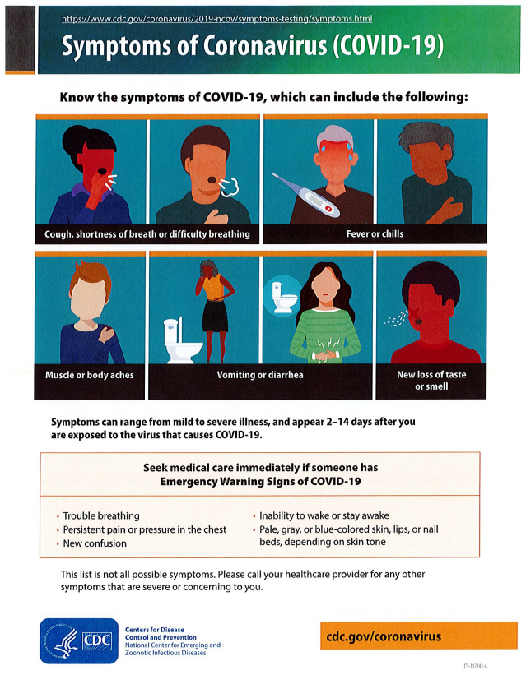
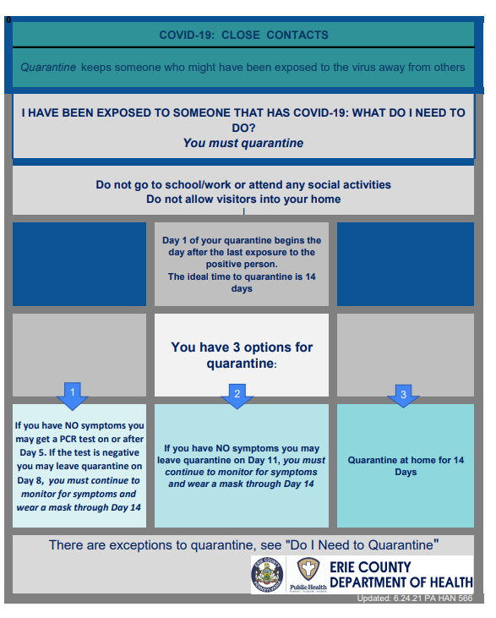

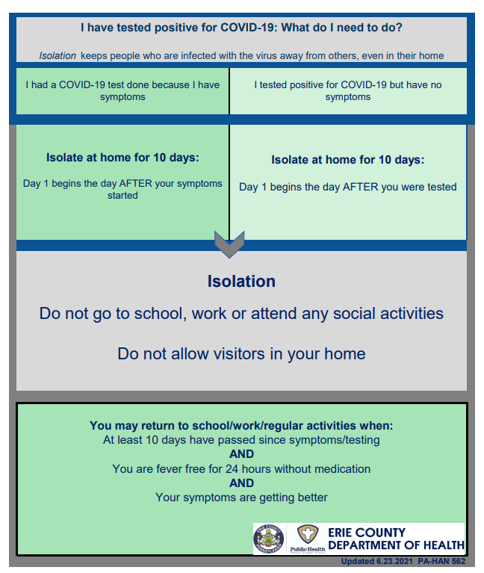

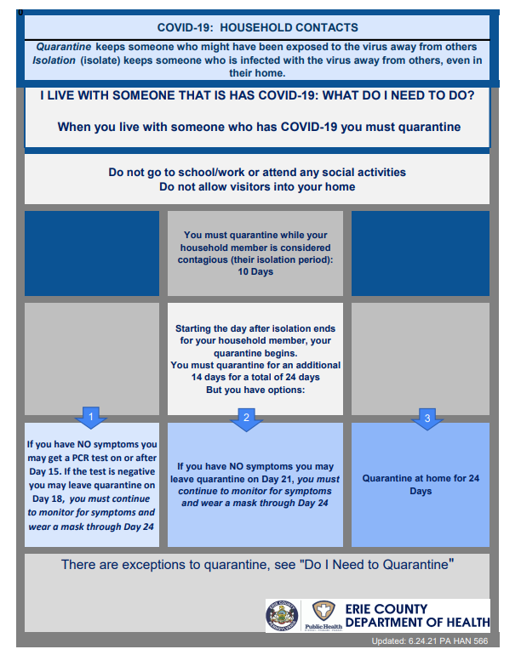

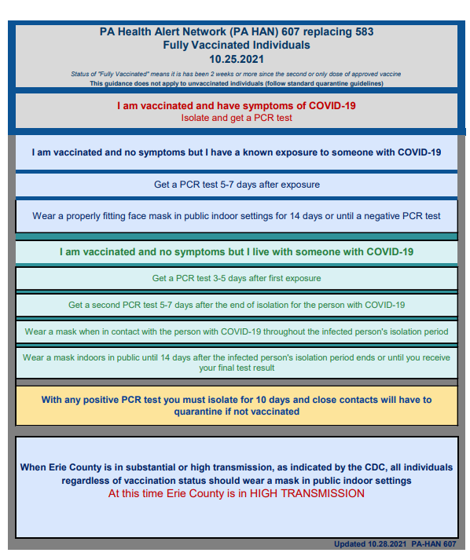

RESOURCES:

https://www.education.pa.gov/Schools/safeschools/emergencyplanning/COVID-19/SchoolReopeningGuidance/ReopeningPreKto12/PublicHealthGuidance/Pages/SchoolClosureRecommentations.aspx

